1. **ADDITION 8085**

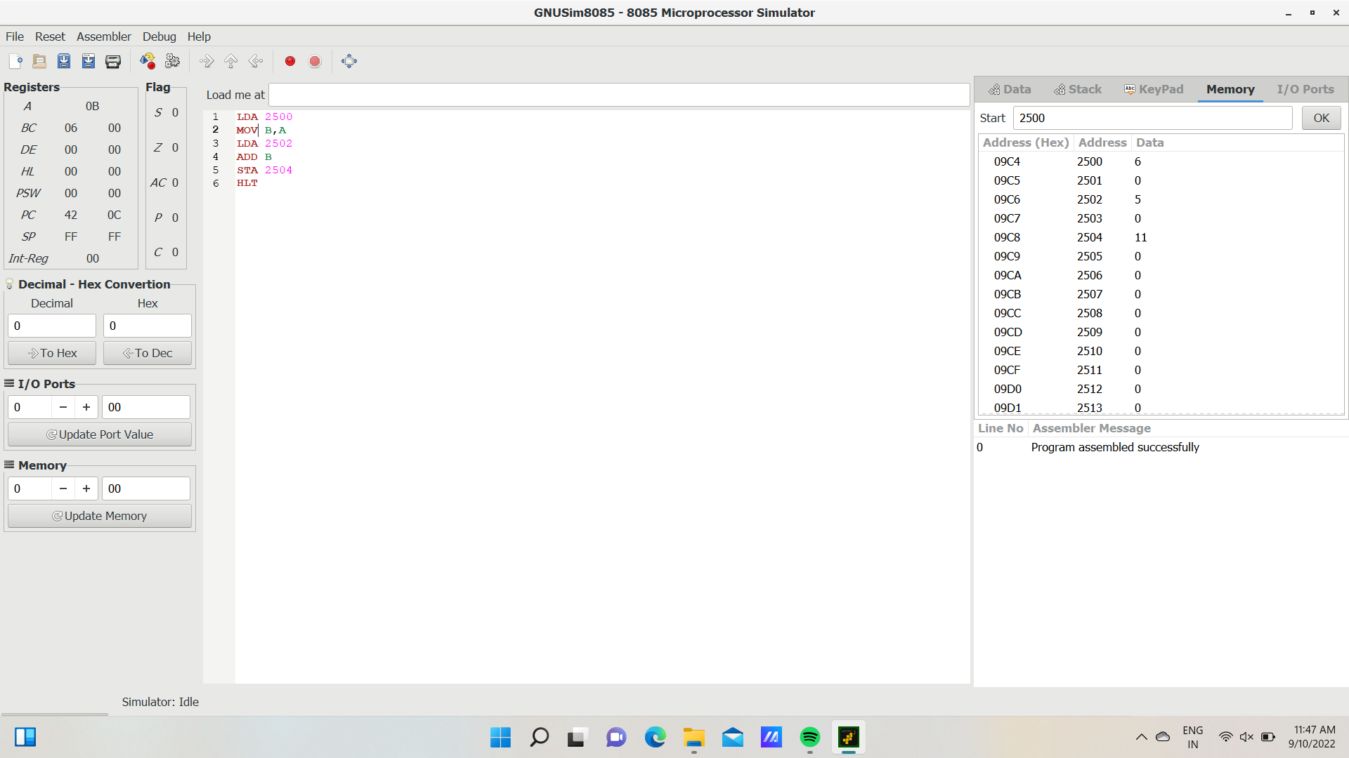

**2.SUBTRACTION 8085**

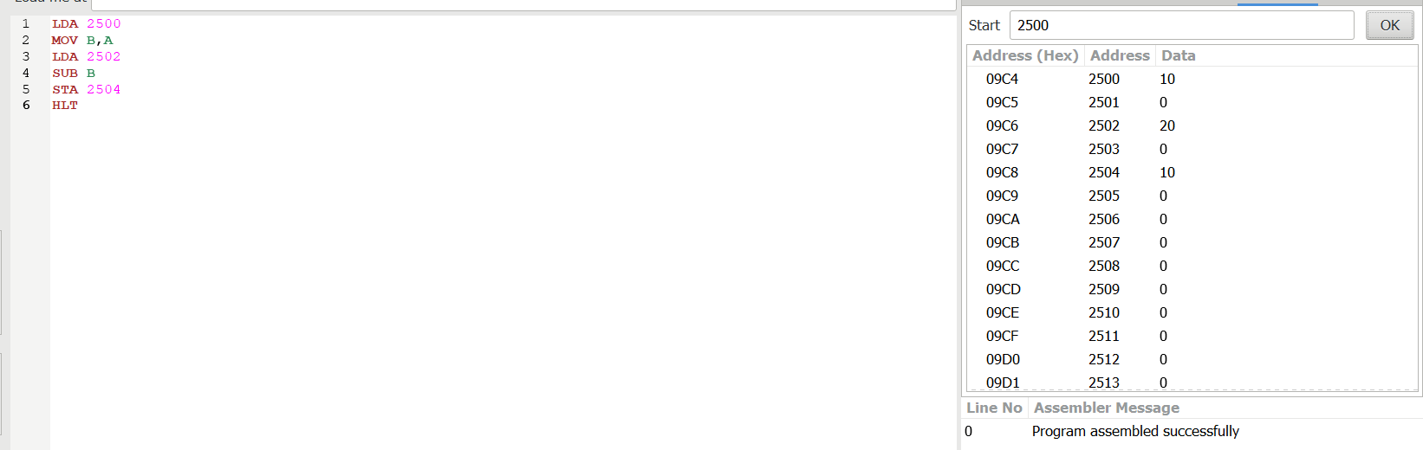

**3.MULTIPLICATION 8085**

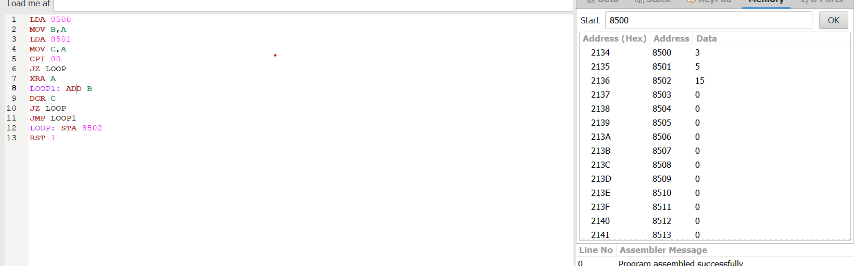

**4.DIVISION 8085**